**MODULE: 5 (JQuery Basic, Effects & Advance)**

**1. What is JQuery?**

**Ans.** jQuery is a fast, small, and feature-rich JavaScript library. It makes things like HTML document traversal and manipulation, event handling, animation, and Ajax much simpler with an easy-to-use API that works across a multitude of browsers. With a combination of versatility and extensibility, jQuery has changed the way that millions of people write JavaScript.

**2. How to Apply CSS Using JQuery, How to Add Class and Remove Class in JQuery, JQuery Animation?**

**Ans.**

**css using Jquery**

**input:**

<!DOCTYPE html>

<html lang="en">

<head>

    <meta charset="UTF-8">

    <meta http-equiv="X-UA-Compatible" content="IE=edge">

    <meta name="viewport" content="width=device-width, initial-scale=1.0">

    <title>Document</title>

    <script src="https://ajax.googleapis.com/ajax/libs/jquery/3.6.0/jquery.min.js"></script>

    <!-- css function start -->

    <script>

        $(document).ready(function()

        {

            $(".b1").click(function()

            {

                $("p").css("background-color","red")

                $("p").css("color","yellow")

            })

            $("div").click(function()

            {

            })

        })

    </script>

    <!-- css function end -->

</head>

<body>

    <p>Please Change My color</p>

    <button class="b1">css</button>

    <button class="b2">Animation</button>

    <div></div>

</body>

</html>

**Output:**

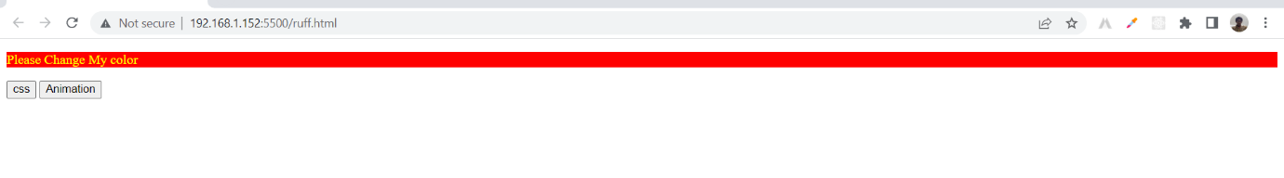

**Add Class Remove Class**

**input:**

<!DOCTYPE html>

<html lang="en">

<head>

    <meta charset="UTF-8">

    <meta http-equiv="X-UA-Compatible" content="IE=edge">

    <meta name="viewport" content="width=device-width, initial-scale=1.0">

    <title>Document</title>

    <script src="https://ajax.googleapis.com/ajax/libs/jquery/3.5.1/jquery.min.js"></script>

    <script>

        // add function

        $(document).ready(function()

        {

            $(".b1").click(function()

            {

                $("h1").addClass("class")

            })

            // remove function

            $(".b2").click(function()

            {

                $("h1").removeClass("class")

            })

        })

    </script>

    <style>

        .class

        {

            color: blue;

        }

    </style>

</head>

<body>

    <h1>

        Comapny Name

    </h1>

    <p>

        Lorem ipsum dolor, sit amet consectetur adipisicing elit. Quidem suscipit eius illum, impedit a culpa delectus ipsum eligendi adipisci, id harum quam, possimus ut eum consequuntur totam ab. Quibusdam, reiciendis?

    </p>

    <!-- button start -->

    <button class="b1">Add CSS</button>

    <button class="b2">Remove CSS</button>

    <!-- button end -->

</body>

</html>

**Output:**

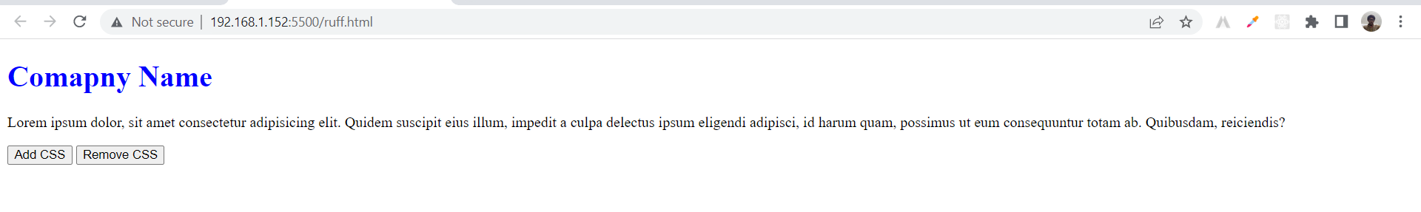

**Jquery Animation**

**input:**

<!DOCTYPE html>

<html lang="en">

<head>

    <meta charset="UTF-8">

    <meta http-equiv="X-UA-Compatible" content="IE=edge">

    <meta name="viewport" content="width=device-width, initial-scale=1.0">

    <title>Document</title>

    <script src="https://ajax.googleapis.com/ajax/libs/jquery/3.6.1/jquery.min.js"></script>

    <style>

        /* css start */

        div

        {

            height: 150px;

            width: 150px;

            background-color: blue;

            left: 50%;

            position: relative;

        }

        /* css end */

    </style>

</head>

<body>

    <button>Left</button>

    <div>

    </div>

    <script>

        // left function start

        $(document).ready(function()

        {

            $("button").click(function()

            {

                $("div").animate({left:'50'});

            })

        })

        // left function end

    </script>

</body>

</html>

**Output:**



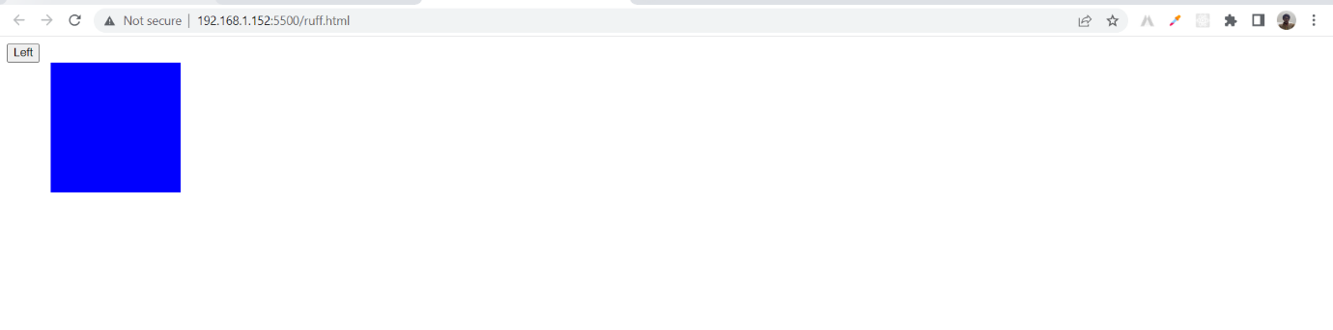

**3. How to create slider with animation?**

**Ans.**

**input:**

<!DOCTYPE html>

<html lang="en">

<head>

    <meta charset="UTF-8">

    <meta http-equiv="X-UA-Compatible" content="IE=edge">

    <meta name="viewport" content="width=device-width, initial-scale=1.0">

    <title>Document</title>

    <script src='https://code.jquery.com/jquery-3.6.0.min.js'></script>

    <!-- cycle.min.js -->

    <script src="https://malsup.github.io/jquery.cycle.all.js"></script>

</head>

<body>

    <div id="slide">

        <!-- first img link -->

        <img src="https://www.freecodecamp.org/news/content/images/2022/04/derick-mckinney-oARTWhz1ACc-unsplash.jpg" height="312px" width="450px" class="slider">

        <!-- second img link -->

        <img src="https://imagekit.io/blog/content/images/2019/12/image-optimization.jpg" height="312px" width="450px" class="slider">

        <!-- third img link -->

        <img src="https://st2.depositphotos.com/1670531/7635/i/600/depositphotos_76357499-stock-photo-top-view-office-desk-mockup.jpg"  height="312px" width="450px" class="slider">

    </div>

        <!-- slider apply here -->

        <script type="text/javascript">

            $(document).ready(function()

            {

                $("#slide").cycle("fade");

                $("#slide img").css("overflow-y","hidden");

            });

        </script>

</body>

</html>

**Output:**

